BIO
Danielle Lord, PhD | Learning & development leader

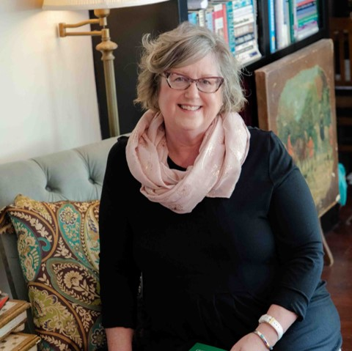
“A well-developed and committed workforce is an amazing asset, which can yield a tremendous competitive advantage when utilized properly”

Prior to starting her own Organizational Development Consulting & Coaching practice, Danielle has developed and led Leadership Development efforts in multiple organizations. This work includes The Port of Seattle, as the Chief Learning Officer for the State of Washington, and for Providence Health and Services, a five-state, 75,000 employee health system.
In addition, she has been a faculty member at Brandman University since 2008, teaching over 17 different graduate level courses. She has also consulted for multiple organizations and developed over 48 courses for organizations of all sizes. Danielle earned her PhD in Leadership Theory in 2007 from Capella University, where she studied nursing dissatisfaction. In addition, she has conducted research into the developmental needs of aspiring physicians and has two business books.
Danielle spent five years in long-term care during the early years of her 25 years in healthcare. While working long-term care, she was very involved in memory care, operations, and served as a regional trainer developing the first state approved Med Cart Administration training and dementia care training.
In her spare time Danielle enjoys antiquing, gardening, and wine. She lives in Auburn with her husband Stephen, and their cat called “kitten, ”and has five adult children.

