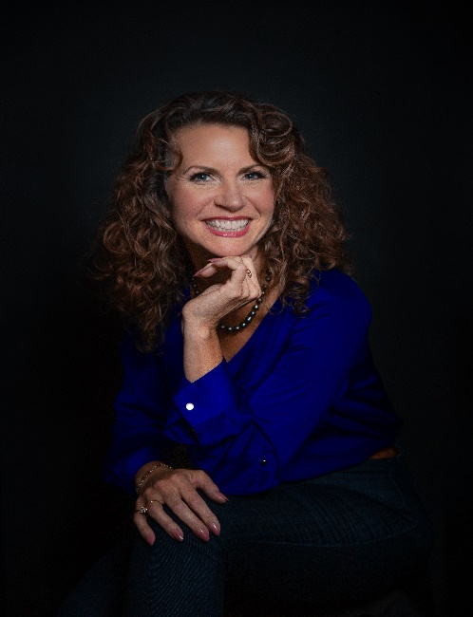
Cami Brecto Renee
“How can I encourage your awesomeness”?

Contact me:
cami@innovatecoachinggroup.com

I used to think my story was boring. In spite of my efforts to make great choices and live a great life, I had the “rug pulled out from under me”… a few times. I had to evaluate my disrupted plans, pivot and learn to dream again. Through it all, I made the intentional choice to live as honestly and lovingly as possible with integrity and with no regrets.

As a life and wellness coach, it is my passion to help people truly live their best lives. Holistic health and well-being has been an area of study for 40+ years, and recently even more so as I had a front row seat with a loved one receiving 24 hour care for 18 months.

Grounded by faith and understanding my purpose - I help people define what success means to them, make confident decisions about all areas of life and help them develop a plan that works for them to live their best lives. I truly believe we are mind, body and soul and our health in one area of life affects the others.

Art has grown to be an integral part of my life. During rough seasons of my life, my art has been a refuge and a safe place. Art recharges me, mind, body and soul. I love to share this skill with others in paint parties and bring art concepts to life with personal development skills and vice versa. I create fun experiential growth opportunities with paint events.

I’ve lived in the northwest for 37 years, raised 4 world-changer kids and now enjoy adult relationships with them and adore my grandkids. I have led local non-profits, mentored teenagers and volunteers, helped small-business owners, spoken to many groups and grown international non-profits.

