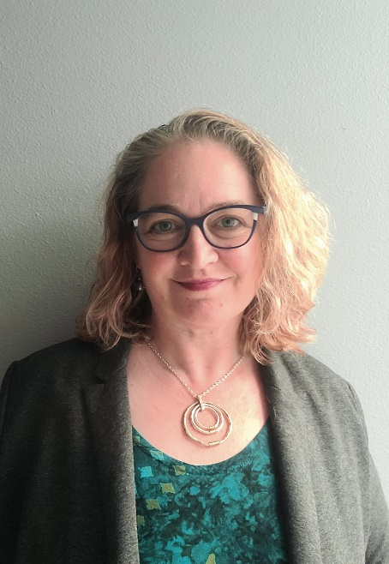

***Anika Klix, M.A. ORGL & HRM*** *(she/her)*

*Anika is an HR Project Manager in the Human Services Department (HSD) at the City of Seattle. Anika launched the Mindful@Work Program at the City, which includes weekly drop-in mindful meditation and movement sessions and a seminar series on the foundations of mindfulness and its benefits for focus, resilience, creativity, and communication in the workplace. She is certified in Mindfulness-Based Stress Reduction (MBSR) and Workplace Mindfulness Facilitation (CWMF) through Mindful Leader and is working toward becoming a certified meditation teacher and certified health and wellness coach.  She is also the editor and publisher of Focused Moments: Creating Shared Experiences and Positive Team Dynamics in Leadership and Engaging Your Employees: 12 Heart-Centered Strategies to Drive Your Organization's Culture and Commitment by Danielle Lord, PhD. Anika has a masters in Human Resources from Claremont Lincoln University and a masters in Organizational Leadership from Gonzaga University.*

*[optional to include] Link to article:*[You Can't Pour from an Empty Cup: The Power of Mindfulness in the Public Sector - Human Interests (seattle.gov)](https://humaninterests.seattle.gov/2024/06/11/you-cant-pour-from-an-empty-cup-the-power-of-mindfulness-in-the-public-sector/)